Editors - Toolbar Editor
Detailed Table of Content 1
Introduction 8
Limits 8
Menus 9
(Un-) Collapse the menus 9
Toolbar Type menu 9
Toolbars Menus 10
Toolbar Settings Bforartists addon 10
Create new toolbar 10
Save Toolbar state 11
Toolbar Types 12
Toolbars File 13
Available Toolbars 13
Toolbars Mesh Edit 15
Available Toolbars 16
Toolbars Primitives 18
Available Toolbars 18
Toolbars Image 21
Available Toolbars 22
Toolbars Tools 23
Available Toolbars 23
Toolbars Animation 25
Available Toolbars 25
Toolbars Edit 27
Available Toolbars 28
Toolbars Misc 30
Available Toolbars 30

Detailed Table of Content

Editors - Toolbar Editor detailed
Detailed Table of Content 1
Introduction 8
Limits 8
Menus 9
(Un-) Collapse the menus 9
Toolbar Type menu 9
Toolbars Menus 10
Toolbar Settings Bforartists addon 10
Create new toolbar 10
Save Toolbar state 11
Toolbar Types 12
Toolbars File 13
Available Toolbars 13
Load / Save 13
Reload Startup file 13
Open Blend File 13
Recent 13
Save Blend File 13
Save As Blend File 13
Save Copy 13
Link Append 13
Link from Library 13
Append from Library 13
Import Common 14
Import FBX 14
Import Obj 14
Import DAE 14
Import BVH 14
Import 3DS 14
Import ABC 14
Import Uncommon 14
Import STL 14
Import PLY 14
Import WRL 14
Import SVG 14
Export Common 14
Export FBX 14
Export Obj 14
Export DAE 14
Export BVH 14
Export 3DS 14
Export ABC 14
Export Uncommon 14
Export 3DS 14
Export PLY 14
Export WRL 14
Render 15
Render Image 15
Render Animation 15
Render Open GL 15
Open GL Render Image 15
Open GL Render Animation 15
Open GL Render Settings 15
Render Misc 15
Mixdown Audio 15
Show/ Hide Renderview 15
Play rendered animation 15
Toolbars Mesh Edit 15
Available Toolbars 16
Vertices Splitconnect 16
Split 16
Vertex Connect Path 16
Vertex Connect 16
Vertices Misc 16
Convex Hull 16
Blend from Shape 16
Shape Propagate 16
Edges Subdiv 16
Subdivide Edge Ring 16
Un-Subdivide 16
Edges Sharp 16
Mark Sharp 16
Unmark Sharp 16
Edges Freestyle 16
Mark Freestyle Edge 16
Unmark Freestyle Edge 16
Edges Rotate 17
Rotate 17
Edges Misc 17
Edge Split 17
Bridge Edgeloops 17
Faces general 17
Fill 17
Grid Fill 17
Beautify Faces 17
Solidify 17
Intersect 17
Boolean Intersect 17
Wire Frame 17
Faces Freestyle 17
Mark Freestyle Face 17
Unmark Freestyle Face 17
Faces Tris 17
Poke Faces 17
Triangulate Faces 17
Tris to Quads 17
Split by Edges 17
Faces Rotate Misc 18
Rotate UV's 18
Reverse UV's 18
Rotate Colors 18
Reverse Colors 18
Cleanup 18
Delete Loose 18
Decimate Geometry 18
Degenerate Dissolve 18
Make Planar Faces 18
Split Non Planar Faces 18
Split Concave Faces 18
Fill Holes 18
Toolbars Primitives 18
Available Toolbars 18
Mesh 18
Add Plane 19
Add Cube 19
Add Circle 19
Add UV Sphere 19
Add Cylinder 19
Add Cone 19
Add Torus 19
Curve 19
Add Bezier 19
Add Circle 19
Add Nurbs Curve 19
Add Nurbs Circle 19
Add Nurbs Path 19
Surface 19
Add Surface Curve 19
Add Surface Circle 19
Add Surface Patch 19
Add Surface Cylinder 19
Add Surface Sphere 19
Add Surface Torus 19
Metaball 19
Add Metaball of type Ball 20
Add Metaball of type Capsule 20
Add Metaball of type Plane 20
Add Metaball of type Elipsoid 20
Add Metaball of type Cube 20
Lamp 20
Add Lamp of type Point 20
Add Lamp of type Sun 20
Add Lamp of type Spot 20
Add Lamp of type Hemi 20
Add Lamp of type Area 20
Other 20
Add Text 20
Add Armature 20
Add Lattice 20
Add Camera 20
Add Speaker 20
Empties 20
Add Empty of type Plain Axes 21
Add Empty of type Sphere 21
Add Empty of type Circle 21
Add Empty of type Cone 21
Add Empty of type Cube 21
Add Empty of type Single Arrow 21
Add Empty of type Arrows 21
Add Empty of type Image 21
Force Field 21
Add Physics Effector of Type Boid 21
Add Physics Effector of Type Charge 21
Add Physics Effector of Type Curve Guide 21
Add Physics Effector of Type Drag 21
Add Physics Effector of Type Force 21
Add Physics Effector of Type Harmonic 21
Add Physics Effector of Type Lennard-Jones 21
Add Physics Effector of Type Magnetic 21
Add Physics Effector of Type Smoke Flow 21
Add Physics Effector of Type Texture 21
Add Physics Effector of Type Turbulence 21
Add Physics Effector of Type Vortex 21
Add Physics Effector of Type Wind 21
Toolbars Image 21
Available Toolbars 22
UV Common 22
Pack Island 22
Average Island Scale 22
Mark Seam 22
Clear Seam 22
Seams from Islands 22
Copy mirrored UV Coordinates 22
UV Misc 22
Unwrap Angle Based 22
Unwrap Conformal 22
Pin 22
Unpin 22
UV Align 23
Weld 23
Remove Doubles UV 23
Align Straighten 23
Align Straighten X 23
Align Straighten Y 23
Align Auto 23
Align X 23
Align Y 23
Toolbars Tools 23
Available Toolbars 23
Relations 23
Create new group 23
Add Selected to active group 23
Remove from Group 24
Remove selected from active Group 24
Remove from all Groups 24
Make Parent 24
Clear Parent 24
Link Data 24
Make Single User 24
Link to SCN 24
Make Local 24
Make Proxy 24
Make Vertex Parent 24
Edit Toolbar 24
Join 24
Set Geometry to Origin 25
Set Origin to Geometry 25
Set Origin to 3D cursor 25
Set Origin to Center of Mass 25
Shade Smooth 25
Shade Flat 25
Transfer Mesh Data 25
Transfer Mesh Data Layout 25
Toolbars Animation 25
Available Toolbars 25
Keyframes 26
Insert Keyframe Menu 26
Delete Keyframe 26
Bake Action 26
Remove Animation 26
Calculate Object Paths 26
Clear Object Paths 26
Range 26
Use Preview Range 26
Lock Frame Selection to Range 26
Frame Start 26
Frame End 26
Play 26
Current Frame 26
Jump to Endpoint 26
Jump to Keyframe 26
Play Animation 26
Play Animation 26
Jump to Keyframe 26
Jump to Endpoint 27
Sync 27
Keyframe Type 27
Keyingset 27
Use Keyframe Insert Auto 27
Keying set Dropdown box 27
Insert Keyframe 27
Delete Keyingset Keyframe 27
Toolbars Edit 27
Available Toolbars 28
Edit 28
Dissolve Vertices 28
Dissolve Edges 28
Dissolve Faces 28
Remove Doubles 28
Limited Dissolve 28
Dissolve Selection 28
Edge Collapse 28
Merge 28
Separate 28
Weigth in Edit 28
Normalize all 29
Normalize 29
Mirror 29
Invert 29
Clean 29
Quantize 29
Levels 29
Smooth 29
Limit Total 29
Fix Deforms 29
Object Apply 29
Location 29
Rotation 29
Scale 29
Rotation & Scale 29
Visual Transform 29
Make Duplicates real 29
Object Apply Deltas 29
Location 29
Rotation 29
Scale 29
All 29
Transforms to Delta Anims 29
Object Clear 29
Location 30
Rotation 30
Scale 30
Origin 30
Toolbars Misc 30
Available Toolbars 30
History 30
Undo 30
Redo 30
Undo History 30
Repeat 30
Repeat History 30
Scene 30
Misc 30

Introduction

The Toolbar editor is what you normally have to avoid in UI design. It's a bunch of double menu entries. It is made by lots of tools that already exists elsewhere.
But the value of this this double menu here is that it is configurable. This customizable toolbar makes it possible to have the most needed tools at top UI level. This can save a ton of clicks, tabbing, scrolling, and digging in sub menus. And you can display what you need for your personal workflow. And hide away the rest.
The toolbar editor uses pure Icon buttons.
Parts of the toolbars are just visible when you are in the right mode. The full Primitives toolbar for example in just visible in Object mode. Parts of it are visible in Edit mode, dependant of what type of object you modify. And in the other modes the toolbars are hidden.
Parts of the toolbars are just visible when the right object type in the scene exists / is selected.
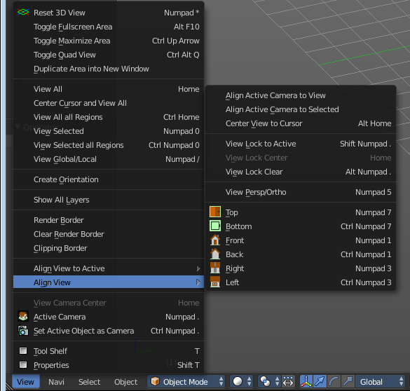
As told, the toolbars are double menu entries. This means te description of the tools in this chapter will be as short as possible. Closer descriptions, like how to use the tools, can be found in the other chapters where the tools comes from. The Tool Shelf in the 3D View for example.

Limits
- The toolbar does not contain all possible tools. More the opposite, the selection is very limited. Lots of tools depends to be performed in the editor type where you want to do the change. They just work there. And not in other editors. And the toolbar is another editor. This limits the available tools in the toolbar dramatically.
The global View buttons to switch to the orthographic views ( Align View) is already a compromise. They change the view in all open 3D view editors. When you want to change the view just in one 3D view, then you have to use the entries in the View menu, or the Numpad hotkeys for them.

- The toolbars have a fixed order. The content is not sortable. The sorting is defined by the order of the toolbar type. And inside the toolbar type by the order in the toolbars menu. You would need to have to edit the python file to change this order.
- Just the toolbar types are independent. The checkboxes to display the toolbars themselves are global. Means when you set one toolbar type to Primitives, and activate all the primitives types there, then other toolbars will have the same primitives types displayed.
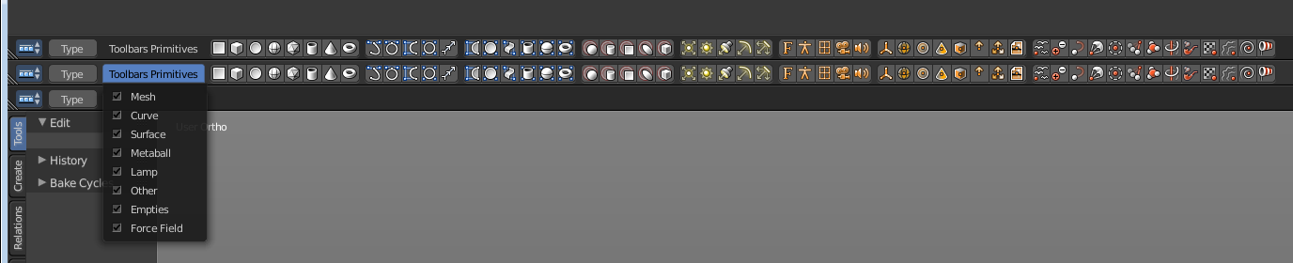

Menus

When you first look at the Toolbar then you will see no visible menus. They exists, but they are hidden away to save UI space. The text menus would eat lots of space that we can better spend in displaying more tools.

The Toolbar Type menu and the Toolbars menus are collapsed. You can expand those menus. This makes it easier to setup. But you can also work with the collapsed menus.

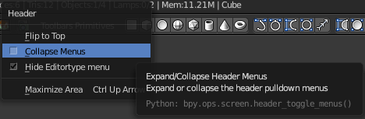
(Un-) Collapse the menus
Right click a the Toolbar. Untick Collapse Menus in the upcoming menu. Then the collapsed menus becomes visible again.
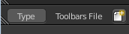

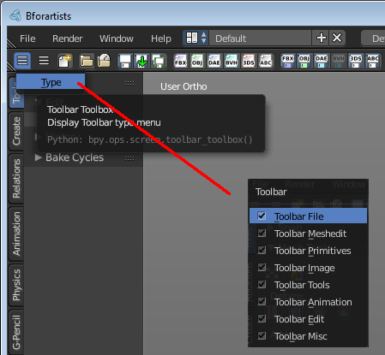
To collapse the menus go the opposite route. Right click a the Toolbar. And tick Collapse Menus in the upcoming menu.

Toolbar Type menu
The first entry of a toolbar is the Toolbar Type menu.
Here you can choose what kind of Toolbar Type you want to show. You can show multiple types of toolbars at once.
The toolbar types are independant from each other. You can set up every toolbar to display different content.

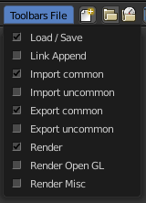
Toolbars Menus
Every toolbar type has several toolbars to display.
In the toolbar menu you can choose what toolbars you want to display.
The toolbars are not independant. This setup is global. When you for example tick the Toolbar File in this toolbar, then it will be displayed in all other toolbars too. Including in other layouts.
These checkboxes are also available in the Toolbar Settings Bforartists addon.

Toolbar Settings Bforartists addon
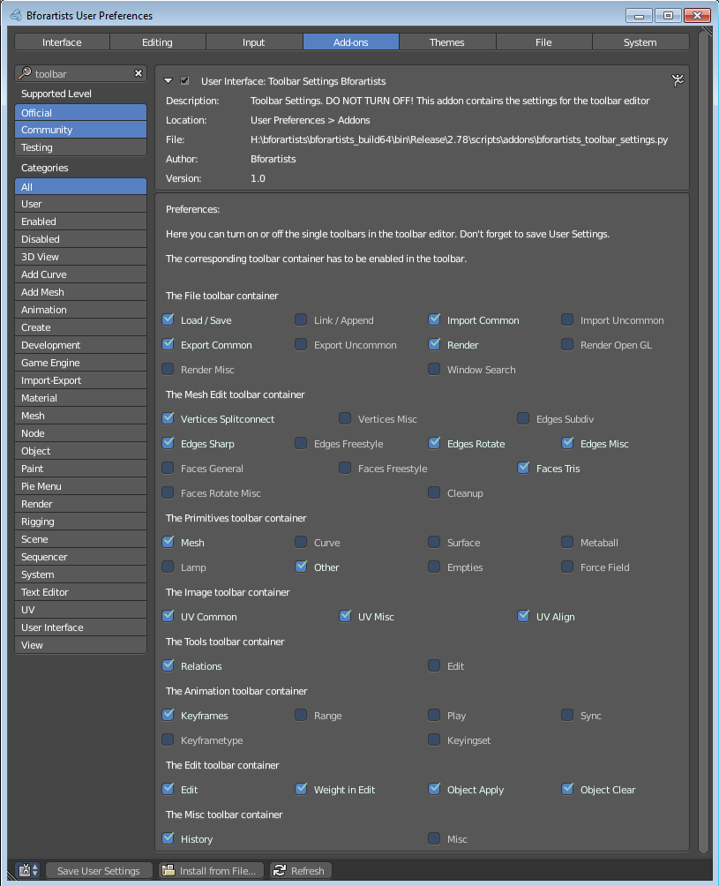
The settings for the toolbar needs to be stored somewhere. This is done in an addon called Toolbar Settings Bforartists.

This addon contains the same checkboxes than the single toolbars menus in the toolbar. But all of them at once. And here is where they get stored when you save the user settings.

Warning!
Do not deactivate this addon. The toolbar will not work then. It depends of the settings in the addon!

Create new toolbar

You might want to create your own toolbar for a new layout. Let's explain the needed steps.

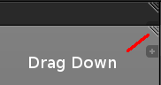
First create a new editor type. This can be done by dragging the triangle area of an existing editor. And will create a new editor.

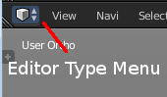
Look at the right of this new created editor type. You will now see a small button. This is the Editor type menu. Open it by clicking at it. And choose Toolbar.

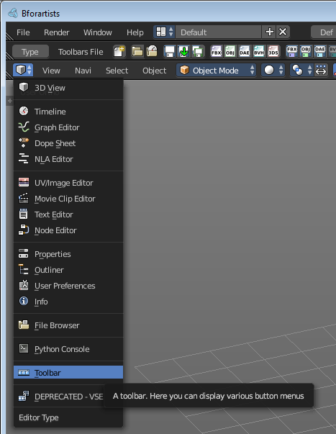

Now set up your new created Toolbar editor. Choose the toolbar types you want to display here. Then choose the toolbars to display.

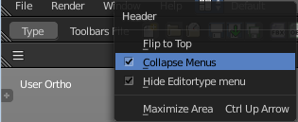
The last step is to hide the Editor Type menu and to collapse the menus. Right click at the toolbar, and tick Collapse Menus and Hide Editortype menu.

Save Toolbar state

You may want to save the changes at the toolbar. Because without saving the changes you will loose them when you reopen Bforartists.

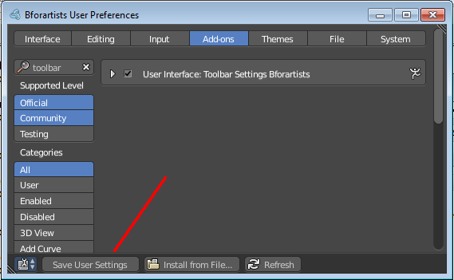
The state of the checkboxes are stored in the Toolbar Settings Bforartists Addon. So to save this part you have to save the User Settings in the User Preferences. It doesn't matter if you have changed the checkboxes in the toolbar or the addon. They are the same.

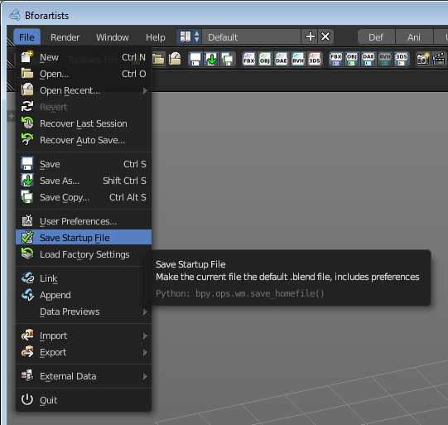
But the state of the collapsed Toolbar menus is not stored in the User Preferences. They are part of the layout. You have to save the startup file to make this changes permanent.

Be careful here. Saving the startup file saves every change at the layout. Including things like having a mesh in the scene.

Toolbar Types

Currently the Toolbar editor contains eight toolbar types.
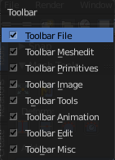
File - Contains some file menu related tools. Like load save. But also the render menu.
Mesh Edit - Contains tools for Meshes in Edit Mode.
Primitives - Contains the primitives from the Create tab in the Tool Shelf.
Image - Contains some tools for editing UV
Tools - Contains the content of the Relations panel in Object mode.
Animation - Contains Animation tools
Edit - Contains some tools from Object and Edit Mode
Misc - Contains Undo, and an empty menu as a place holder.
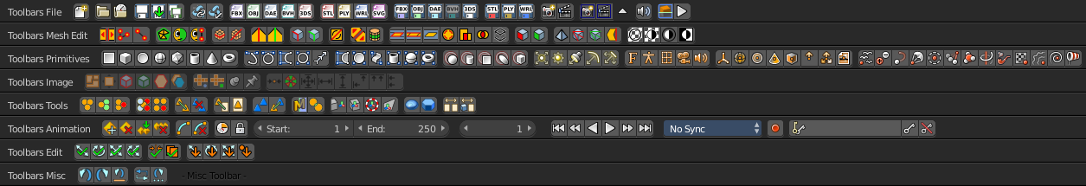

Toolbars File

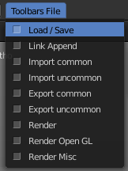
The Toolbars File contains some file menu related tools. Like load save. But also the render menu.

These toolbars are available in all modes.

Available Toolbars
The description of the single buttons goes from left to right.

Load / Save
The original menu items are in the File menu of the Info editor.

Reload Startup file
Creates a new scene.

Open Blend File
Load a Blend file.

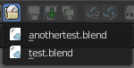
Recent
The recent files menu.

Save Blend File
Save a Blend file.

Save As Blend File
Save a Blend file as.

Save Copy
Saves a copy of the Blend file.

Link Append
The original menu items are in the File menu of the Info editor.

Link from Library
Link contend from a Blend file

Append from Library
Append content

Import Common
The original menu items are in the File menu of the Info editor.

Import FBX
Import FBX files.

Import Obj
Import Object files.

Import DAE
Import Collada files.

Import BVH
Import Biovision Motion Capture files.

Import 3DS
Import 3DS files.

Import ABC
Import Alembic files.

Import Uncommon
The original menu items are in the File menu of the Info editor.

Import STL
Import STL files

Import PLY
Import PLY files.

Import WRL
Import X3D or VRML2 files.

Import SVG
Import SVG Files.

Export Common
The original menu items are in the File menu of the Info editor.

Export FBX
Export as FBX file.

Export Obj
Export as Obj file.

Export DAE
Export as Collada file.

Export BVH
Export as BVH Motion Capture file.

Export 3DS
Export as 3DS file.

Export ABC
Export as Alembic file.

Export Uncommon
The original menu items are in the File menu of the Info editor.

Export 3DS
Export as 3DS.

Export PLY
Export as PLY file.

Export WRL
Export as X3D or VRML2 files.

Render
The original menu items are in the Render menu of the Info editor.

Render Image
Renders the current scene as an image by using the current offline renderer. Either Blender Internal or Cycles.

Render Animation
Renders the current scene as an animation. Either Blender Internal or Cycles.

Render Open GL
The Render Open GL toolbar is made of three tools.

Open GL Render Image
Renders the current scene as an image by using the Viewport and Open GL.

Open GL Render Animation
Renders the current scene as an animation by using the Viewport and Open GL.

Open GL Render Settings
The triangle button contains the Open GL Render settings.

Render Misc
The original menu items are in the Render menu of the Info editor.

Mixdown Audio
Mixdown and export the scene's audio to an audio file.

Show/ Hide Renderview
Toggles display of Render view.

Play rendered animation
Play rendered Animation sequence.

Toolbars Mesh Edit

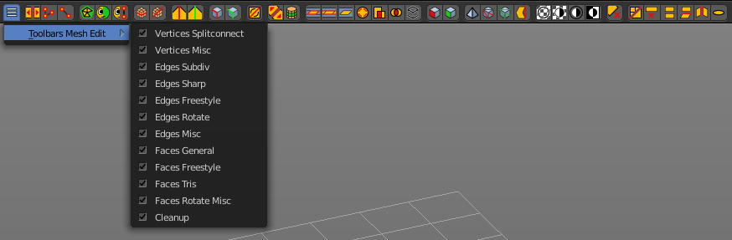
The Toolbars Mesh Edit contains tools for Mesh Objects in Edit Mode. The original menu items are mainly in the Mesh menu in Edit Mode. In the Vertices, Edges and Faces submenus.

This toolbars shows its content Edit mode.

Available Toolbars
The description of the single buttons goes from left to right.

Vertices Splitconnect

Split
Splits two connected Vertices.

Vertex Connect Path
Connect Vertices by their seleciton order, creating edges, splitting faces

Vertex Connect
Connect selected vertices of faces, splitting the face.

Vertices Misc

Convex Hull
Enclose selected vertices in a convex polyhedron.

Blend from Shape
Blend in shape from a shapekey.

Shape Propagate
Apply selected vertex locations to all other shapekeys.

Edges Subdiv

Subdivide Edge Ring
Subdivides an Edge Ring

Un-Subdivide
Unsubdivides selected edges and faces.

Edges Sharp

Mark Sharp
Mark selected edges as sharp.

Unmark Sharp
Unmark selected edges as sharp.

Edges Freestyle

Mark Freestyle Edge
Mark selected edges as Freestyle feature edges.

Unmark Freestyle Edge
Unmark selected edges as Freestyle feature edges.

Edges Rotate

Rotate
Rotate selected edges or adjoining faces.

Edges Misc

Edge Split
Split selected edges so tthat each neighbour face gets its own copy.

Bridge Edgeloops
Create faces between selected edge loops.

Faces general

Fill
Fill a selected edge loop with faces.

Grid Fill
Fill grid from two loops.

Beautify Faces
Rearrange some faces to minimize degenerations.

Solidify
Create a solid skin by extruding. Compensating for sharp angles.

Intersect
Cut an intersection into faces.

Boolean Intersect
Cut solid geometry from selected to unselected.

Wire Frame
Create a solid wire frame from faces.

Faces Freestyle

Mark Freestyle Face
Mark selected faces for exclusion from freestyle feature edge detection.

Unmark Freestyle Face
Unmark selected faces for exclusion from freestyle feature edge detection.

Faces Tris

Poke Faces
Split a face into a fan.

Triangulate Faces
Triangulates selected faces.

Tris to Quads
Join triangle faces into quads.

Split by Edges
Split faces by loose edges.

Faces Rotate Misc

Rotate UV's
Rotate UV coordinates inside faces.

Reverse UV's
Flip direction of UV coordinates inside faces.

Rotate Colors
Rotate Vertex Colors inside faces.

Reverse Colors
Flip direction of Vertex Colors inside faces.

Cleanup

Delete Loose
Delete loose vertices, edges or faces.

Decimate Geometry
Simplify geometry by collapsing edges.

Degenerate Dissolve
Dissolve zero area faces and zero length edges.

Make Planar Faces
Flatten selected faces.

Split Non Planar Faces
Split non planar faces that exceeds the angle threshold.

Split Concave Faces
Make all faces convex.

Fill Holes
Fill in holes (boundary edge loops)

Toolbars Primitives

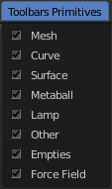
The toolbars Primitives contains the Add items from the Create tab.

The full toolbar with all its content is just available in Object mode. In other modes it hides away. Single types are also visible in Edit mode. When you work at an mesh type, then the Mesh primitives toolbar is visible for example.

Available Toolbars
The description of the single buttons goes from left to right.

Mesh
The Mesh toolbar contains the Mesh primitives.
The original menu items are in the Tool Shelf in the 3D View, in the Create tab in the Add Primitives Panel.

Add Plane
Add a Plane primitive.

Add Cube
Add a Cube primitive.

Add Circle
Add a Circle primitive.

Add UV Sphere
Add a UV Sphere primitive.

Add Cylinder
Add a Cylinder primitive.

Add Cone
Add a Cone primitive.

Add Torus
Add a Torus primitive.

Add Grid
Add a Grid primitive.

Curve
The Curve toolbar contains the Curve primitives.
The original menu items are in the Tool Shelf in the 3D View, in the Create tab in the Add Primitives Panel.

Add Bezier
Add a Bezier curve primitive.

Add Circle
Add a Circle curve primitive.

Add Nurbs Curve
Add a Nurbs Curve primitive.

Add Nurbs Circle
Add a Nurbs Circle curve primitive.

Add Nurbs Path
Add a Nurbs Path curve primitive.

Surface
The Surface toolbar contains the Surface primitives.
The original menu items are in the Tool Shelf in the 3D View, in the Create tab in the Add Primitives Panel.

Add Surface Curve
Add a Nurbs Surface curve primitive.

Add Surface Circle
Add a Nurbs Surface Circle primitive.

Add Surface Patch
Add a Nurbs Surface Patch primitive.

Add Surface Cylinder
Add a Nurbs Surface Cylinder primitive.

Add Surface Sphere
Add a Nurbs Surface Sphere primitive.

Add Surface Torus
Add a Nurbs Surface Torus primitive.

Metaball
The metaball toolbar contains the Metaball primitives.
The original menu items are in the Tool Shelf in the 3D View, in the Create tab in the Add Primitives Panel.

Add Metaball of type Ball
Add Metaball of type Ball primitive.

Add Metaball of type Capsule
Add Metaball of type Capsule primitive.

Add Metaball of type Plane
Add Metaball of type Plane primitive.

Add Metaball of type Elipsoid
Add Metaball of type Elipsoid primitive.

Add Metaball of type Cube
Add Metaball of type Cube primitive.

Lamp
The Lamp toolbar contains the different lamp types.
The original menu items are in the Tool Shelf in the 3D View, in the Create tab in the Add Misc Panel.

Add Lamp of type Point
Add Lamp of type Point.

Add Lamp of type Sun
Add Lamp of type Sun.

Add Lamp of type Spot
Add Lamp of type Spot.

Add Lamp of type Hemi
Add Lamp of type Hemi.

Add Lamp of type Area
Add Lamp of type Area.

Other
The Other toolbar contains some other ground types like bones and text.
The original menu items are in the Tool Shelf in the 3D View, in the Create tab in the Add Misc Panel.

Add Text
Add a Text object.

Add Armature
Add a Armature object.

Add Lattice
Add a Lattice object.

Add Camera
Add a Camera object.

Add Speaker
Add a Speaker object.

Empties
The Empties toolbar contains the available empty types.
The original menu items are in the Tool Shelf in the 3D View, in the Create tab in the Add Misc Panel.

Add Empty of type Plain Axes
Add Empty of type Plain Axes.

Add Empty of type Sphere
Add Empty of type Sphere.

Add Empty of type Circle
Add Empty of type Circle.

Add Empty of type Cone
Add Empty of type Cone.

Add Empty of type Cube
Add Empty of type Cube.

Add Empty of type Single Arrow
Add Empty of type Single Arrow.

Add Empty of type Arrows
Add Empty of type Arrows.

Add Empty of type Image
Add Empty of type Image.

Force Field
The Force Field toolbar contains the available Force field types.
The original menu items are in the Tool Shelf in the 3D View, in the Create tab in the Add Misc Panel.

Add Physics Effector of Type Boid
Add Physics Effector of Type Boid.

Add Physics Effector of Type Charge
Add Physics Effector of Type Charge.

Add Physics Effector of Type Curve Guide
Add Physics Effector of Type Curve Guide.

Add Physics Effector of Type Drag
Add Physics Effector of Type Drag.

Add Physics Effector of Type Force
Add Physics Effector of Type Force.

Add Physics Effector of Type Harmonic
Add Physics Effector of Type Harmonic.

Add Physics Effector of Type Lennard-Jones
Add Physics Effector of Type Lennard-Jones.

Add Physics Effector of Type Magnetic
Add Physics Effector of Type Magnetic.

Add Physics Effector of Type Smoke Flow
Add Physics Effector of Type Smoke Flow.

Add Physics Effector of Type Texture
Add Physics Effector of Type Texture.

Add Physics Effector of Type Turbulence
Add Physics Effector of Type Turbulence.

Add Physics Effector of Type Vortex
Add Physics Effector of Type Vortex.

Add Physics Effector of Type Wind
Add Physics Effector of Type Wind.

Toolbars Image

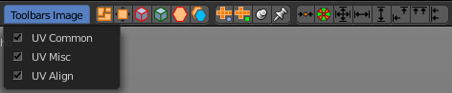
The toolbars Image contains some image related tools. At the moment this toolbar contains just tools to edit UV meshes. This means that you have to be in Edit mode with an UV mapped mesh to make the tools active.
The original menu items are in the Image menu of the UV Image Editor.

Available Toolbars
The description of the single buttons goes from left to right.

UV Common
The UV Common toolbar contains some often used UV tools.

Pack Island
Packs the UV patches so that they fit best into the UV space, and as few texturespace as possible is wasted.

Average Island Scale
Average the size of separated UV patches, based at their size in 3D space.

Mark Seam
Mark selected UV Edges as Seam.

Clear Seam
Remove Seam from selected UV Edges.

Seams from Islands
Marks the border edges of the UV patches as Seam.

Copy mirrored UV Coordinates
Copy mirrored UV Coordinates at X axis based on a mirrored mesh.

UV Misc
The UV Misc toolbar contains buttons to unwrap with Angle Based and Conformal method, and buttons to pin and unpin.

Unwrap Angle Based
Unwraps the selected geometry with the Angle based ( ABF ) method.

Unwrap Conformal
Unwraps the selected geometry with the Conformal ( LSCM ) method.

Pin
Pins the selected vertices.

Unpin
Unpins the selected verstices.

UV Align
The UV Align toolbar contains tools to clean up and align the selected UV geometry.

Weld
Welds the selected UV vertices

Remove Doubles UV
Removes double vertices

Align Straighten
Align UV's along the line defined by the end points of the selection.

Align Straighten X
Align UV's along the line defined by the end points along the X axis.

Align Straighten Y
Align UV's along the line defined by the end points along the Y axis.

Align Auto
Automatically choose the axis on which there is most alignmend already.

Align X
Align UV's at X axis

Align Y
Align UV's at Y axis

Toolbars Tools

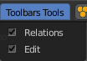
The Toolbars Tools contains some tools in object mode. The content from the relations panel and the edit panel in the tool shelf. And one tool in Edit mode. Make Vertex Parent. Since this is also part of the relations panel.

Available Toolbars
The description of the single buttons goes from left to right.

Relations

The Relations toolbar contains the content from the relations panel from the tool shelf in Object mode. And one tool in Edit mode. Make Vertex Parent. Since this is also part of the relations panel.

Create new group
Creates a new group.

Add Selected to active group
Adds the selected object to the active group.

Remove from Group
Removes the selected object from the group.

Remove selected from active Group
Removes the selected object from the active group.

Remove from all Groups
Removes the selected object from all groups.

Make Parent
Parents the selected object to the active object.

Clear Parent
Removes the parenting.

Link Data
Apply active object links to other selected objects.

Make Single User
Make linked data local to each object.

Link to SCN
Link selection to another scene.

Make Local
Make library linked datablocks local to this file

Make Proxy
Add empty object to become local replacement data of a library linked object.

Make Vertex Parent
Parents the selected object to a vertex of another object. - This item exists in edit mode.

Edit Toolbar
The Edit toolbar contains the content from the Edit panel from the tool shelf in Object mode.

Join
Join selected objects into active objects.

Set Geometry to Origin
Sets the geometry to origín.

Set Origin to Geometry
Sets the origin to geometry.

Set Origin to 3D cursor
Sets the origin to the 3D cursor.

Set Origin to Center of Mass
Sets the origin to the center of mass.

Shade Smooth
Shades the geometry smooth.

Shade Flat
Shades the geometry flat.

Transfer Mesh Data
Transfers mesh data.

Transfer Mesh Data Layout
Transfers the mesh data layout

Toolbars Animation

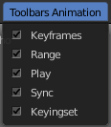
The Toolbars Animation contains tools around animation. The Toolbars Range, Play, Sync and Keyingset are the toolbars from the Timeline. But separated into four independant parts.

Available Toolbars
The description of the single buttons goes from left to right.

Keyframes
The Keyframes toolbar contains some keyframe tools. The original menu items can be found in the Tool Shelf in the Animation tab in the Animation panel.
The original menu items are in the Tool Shelf in the 3D View, in the Animation tab in the Animation panel.

Insert Keyframe Menu
When there is no keying set assigned to the currently selected object ,then this button is a menu where you can choose a keying set. When there is already a keying set assigned, then you can record a keyframe with this button

Delete Keyframe
Deletes the current Keyframe

Bake Action
Bakes the animation to a new action

Remove Animation
Remove all keyframe animation for selected objects

Calculate Object Paths
Calculate motion paths for the selected objects.

Clear Object Paths
Clears motion paths for the selected objects.

Range

Use Preview Range
Use an alternative start/end frame grange for animation playback and OpenGL renders instead of the Render Properties start/end frame range.

Lock Frame Selection to Range
Don't allow frame to be selected with mouse outside of frame range

Frame Start
The frame start point

Frame End
The frame end point

Play

Current Frame
The current frame number

Jump to Endpoint
Jumps to beginning of animation

Jump to Keyframe
Jumps to the previous keyframe Play Animation

Play Animation
Plays animation reversed

Play Animation
Plays animation forward

Jump to Keyframe
Jumps to next keyframe

Jump to Endpoint
Jumps to end of animation

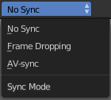
Sync
Sync is a dropdown box where you can adjust the syncing method.

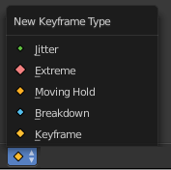
Keyframe Type
Keyframe Type is a dropdown box where you can choose in what color the keyframe gets displayed in the Dope Sheet Editor.

Keyingset

Use Keyframe Insert Auto
Auto insert keyframes at manipulation.

Keying set Dropdown box
This is a dropdown box where you can choose the keyingset method.

Insert Keyframe
Insert a keyframe.

Delete Keyingset Keyframe
Delete Keyframe.
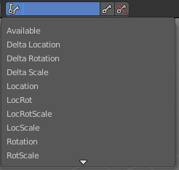

Toolbars Edit

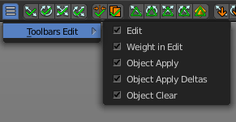
The Toolbars Edit contains various toolbars around editing. Some content just shows when an object exists in the scene. Some content is visible in Object mode. Some content is visible in Edit mode.

Available Toolbars
The description of the single buttons goes from left to right.

Edit
The Edit toolbar is just visible in Edit Mode. The original menu items are in the Tool Shelf in the 3D View in the Tools tab in the Mesh Tools panel.

Dissolve Vertices
Dissolve Vertices.

Dissolve Edges
Dissolve Edges.

Dissolve Faces
Dissolve Faces.

Remove Doubles
Removes double vertices.

Limited Dissolve
Dissolve Edges and Vertices limited by the surrounding angle.

Dissolve Selection
Dissolve Geometry dependant of selection mode.

Edge Collapse
Collapse selected edges.

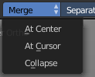
Merge
Merges selected geometry. This is a dropdown box where you can choose where to merge.

Separate
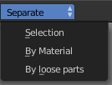
Separate the selection, and create a new object from it. This is a dropdown box where you can choose the separate method.

Weigth in Edit
The Weight in Edit toolbar is just visible in Edit Mode for normal meshes, and Pose mode when you have a rigged character selected. The original menu items are in the Tool Shelf in the 3D View in the Tools tab in the Weight Tools panel. You need to have a Vertex Group applied.

Normalize all
Normalizes the whole mesh.

Normalize
Normalizes the selection

Mirror
Mirrors the selection.

Invert
Inverts the weighting.

Clean
Remove Vertex Assignments that are not required.

Quantize
Set Weights to a fixed number of steps.

Levels
Add some offset and multiply with some gain the weights of the active vertex group.

Smooth
Smooth weights for selected vertices.

Limit Total
Limit deform weights.

Fix Deforms
Fix Deforms by modifying the position of selected vertices.

Object Apply
The Object Apply toolbar is just visible in Object Mode. The original menu items are in the Object menu in the 3D View. The Apply menu.

Location
Apply location.

Rotation
Apply Rotation.

Scale
Apply Scale.

Rotation & Scale
Apply Rotation, Scale.

Visual Transform
Apply Visual Transform.

Make Duplicates real
Make Duplicates attached to this object real.

Object Apply Deltas
Object Apply deltas converts normal object transforms to delta transforms. Any existing delta transform will also be included.

Location
Apply location.

Rotation
Apply Rotation.

Scale
Apply Scale.

All
Apply Location, Rotation, Scale.

Transforms to Delta Anims
Convert object animation for normal transforms to delta transforms

Object Clear
The Object Clear toolbar is just visible in Object Mode. The original menu items are in the Object menu in the 3D View. The Clear menu.

Location
Resets the position of the object to zero

Rotation
Resets the object's rotation to zero

Scale
Resets the object's scale to 1

Origin
Resets the Origin Position

Toolbars Misc

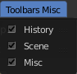
The Toolbars Misc contains some miscellaneous tools.

Available Toolbars
The description of the single buttons goes from left to right.

History
The History toolbar contains Undo, Redo and History. The original menu items are in the Tool Shelf in the 3D View. In the Tools tab in the History panel.

Undo
Undo the last step

Redo
Redo the last undone step

Undo History
A list of last operations where you can undo more than one step

Repeat
Repeats the last action

Repeat History
A list of the last actions where you can choose from

Scene
The Scene dropdown box to choose and create a new scene data block. The original dropdown box is in the Properties editor in the Scene tab in the Scene panel.

Misc
The Misc toolbar is currently empty besides a placeholder string.

